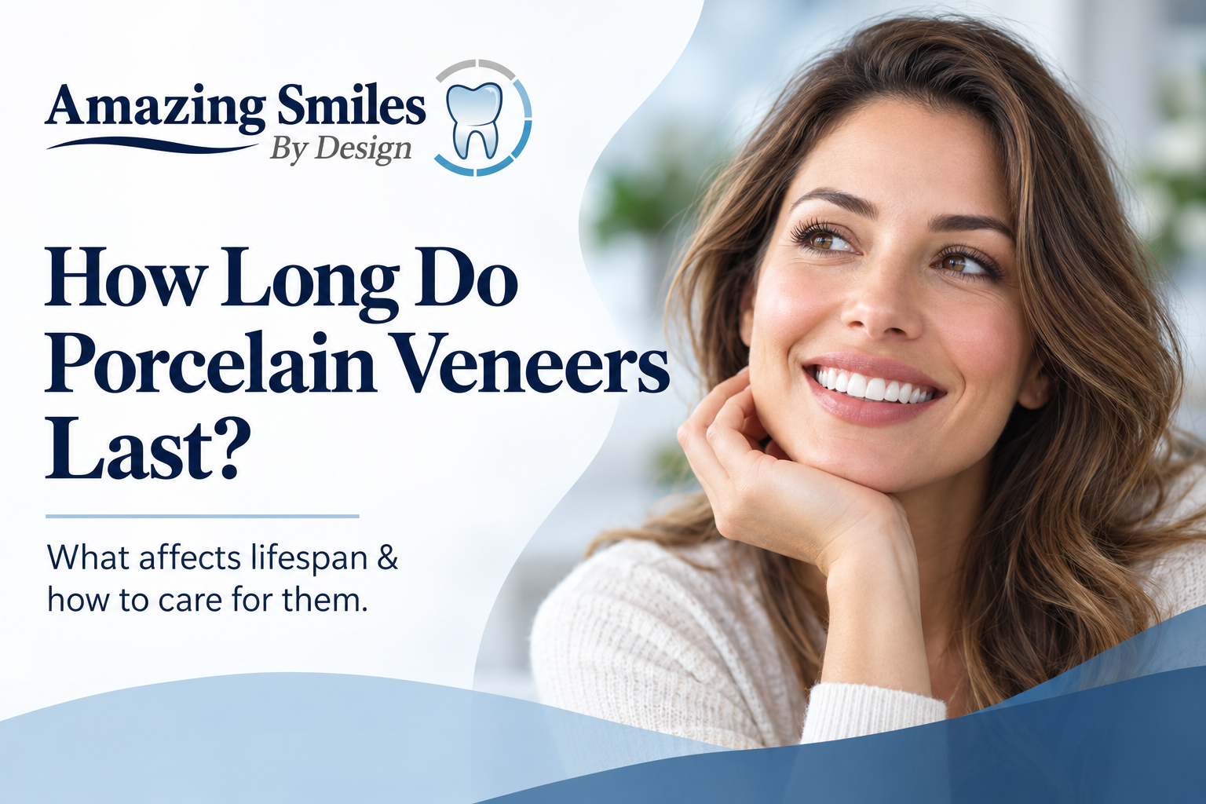How Long Do Porcelain Veneers Last?
Dr. Keyur Dudhat, DMD, Amazing Smiles By Design · Published 6 October 2026 · Updated 6 October 2026
QUICK ANSWER
Porcelain veneers usually last 10 to 15 years, and up to about 20 with good care. How long yours last depends on a few things you control, like grinding, biting hard objects and daily cleaning, and a few your dentist controls, like the fit and the bond. When a veneer wears out, it is replaced rather than repaired.

Key Takeaways
- Most porcelain veneers last 10 to 15 years, and well-cared-for ones can reach about 20.
- Composite veneers are cheaper upfront but usually last about 5 to 7 years.
- Grinding at night is the single biggest thing that shortens veneer life, and a night guard helps.
- Veneers do not decay, but the tooth underneath still can, so brushing and flossing still matter.
- A veneer is replaced, not repaired, so good habits delay the next cost.

How Long Do Porcelain Veneers Really Last?
Porcelain veneers typically last 10 to 15 years, and many last up to about 20 years when they are looked after well. They are thin shells of dental porcelain bonded to the front of your teeth, and the porcelain itself does not stain or decay. What wears out over time is the bond and the edges, and the natural tooth behind the veneer, which is why daily care still counts.
Here is how porcelain compares with the other common options at a glance.
Option | Typical lifespan | What it's best for
Porcelain veneers | 10–15 years (up to about 20 with great care) | Chips, gaps, stains that won't whiten, reshaping
Composite / bonding | 5–7 years | Smaller fixes, a lower upfront cost
Dental crown | 5–15 years | A tooth that is badly damaged or weak

When any of these wears out, it is replaced. A veneer cannot usually be patched, so the habits below are what keep the replacement date as far away as possible.

Porcelain vs Composite Veneers: Which Lasts Longer?
Porcelain lasts longer. Porcelain veneers hold up for 10 to 15 years or more, while composite (resin) options usually last about 5 to 7 years. Composite costs less at the start and can often be repaired in the chair, but it stains and chips sooner. Porcelain costs more upfront and tends to cost less per year over its life because you replace it far less often. If a smaller change would do, tooth-colored dental bonding is the lower-cost route. At your cosmetic consultation, we'll tell you honestly which option suits your teeth, your goals and your budget.

What Affects How Long Your Veneers Last?
Two sets of things decide how long a veneer lasts: what your dentist controls, and what you control day to day.
*What your dentist controls:*
- How well the veneer fits the tooth and the bite
- The strength of the bond to healthy enamel
- Whether the tooth underneath was healthy before the veneer went on
*What you control:*
- Grinding or clenching, especially at night
- Using your teeth as tools to open packaging or bite nails
- Chewing very hard foods like ice or hard candy
- Daily brushing and flossing, which protects the tooth behind the veneer
- Keeping your regular checkups and cleanings
The dentist's part is a one-time thing done well at placement. Your part is what adds the extra years.

How to Make Your Porcelain Veneers Last Longer
You can add years to your veneers with a few simple habits:
- Brush twice a day with a non-abrasive, fluoride toothpaste, and skip whitening pastes, which are gritty.
- Floss daily to protect the gum and the tooth edge where the veneer meets it.
- Wear a night guard if you grind or clench while you sleep.
- Wear a mouthguard for contact sports.
- Don't bite ice, pens, fingernails or packaging.
- Keep your six-month checkups so small problems are caught while they are still small.
None of this is dramatic. It is the same care that keeps natural teeth healthy, with a little extra protection against grinding.

Signs Your Veneers Need Replacing
Veneers give you some warning before they fail. Book a visit if you notice any of these:
- A chip, crack or rough edge you can feel with your tongue
- A veneer that feels loose or clicks
- A dark line or gap appearing at the gum
- Sensitivity to hot or cold that is new
- Staining around the edge of a veneer that cleaning won't shift
Caught early, a single worn veneer can often be replaced on its own, before it affects the teeth next to it.

Do Veneers Last Longer Than Crowns?
They last about the same, but they do different jobs. A veneer covers the front of a tooth to improve how it looks, and lasts 10 to 15 years or more. A crown covers the whole tooth to protect one that is cracked, worn or heavily filled, and lasts around 5 to 15 years. If a tooth is mainly a cosmetic concern, a veneer is usually the more conservative choice because less of the tooth is reshaped. If the tooth is damaged or weak, a dental crown protects it better. We will recommend whichever one is right for the tooth, not the other way around.

What Veneers Cost in Bensalem, and How to Pay for Them
The cost of veneers depends on how many teeth you treat and the material you choose, so the honest answer is that you will get an exact figure at your consultation, not before. A few things that help:
- Membership plan: members get 20% off cosmetic treatment, including veneers. See the membership plans.
- Financing: monthly payments are available through CareCredit and Cherry. See financing options.
- Insurance: veneers are usually considered cosmetic, so most plans don't cover them, but coverage depends on your plan and we will check it with you.
If your goal is a whiter smile rather than a change in shape, teeth whitening or dental bonding may get you there for less, and we will say so.
Want an exact figure for your own teeth? A consultation is the only way to get one.
▸ Book a Cosmetic Consultation (/patient-information/scheduling/)
No pressure: if whitening or bonding would get you there for less, we'll say so.

Caring for Your Smile at Amazing Smiles By Design
Dr. Keyur Dudhat places and maintains porcelain veneers at Amazing Smiles By Design in Bensalem, PA. Some patients come to us new to veneers; others already have a set that's getting old. Either way, you'll get a clear answer about what will last and what it takes to get there.
▸ Book a Cosmetic Consultation (/patient-information/scheduling/)
▸ Call or Text (215) 639-5331 (tel:+12156395331)
IMAGE PLACEHOLDER — leave blank; practice-supplied photo.
Developer / designer: optional single in-body image slot, left blank for a practice-supplied photo of the Bensalem office or Dr. Dudhat. Do not use stock or AI imagery. WebP, width/height set, descriptive alt text added when supplied. A before/after photo may only be used here with the patient's written consent.

Porcelain Veneer FAQs

How long do porcelain veneers last on average?
Porcelain veneers last about 10 to 15 years on average, and up to about 20 years with good care. The porcelain does not stain or decay, so what wears out over time is the bonded edge and the natural tooth underneath, which is why daily cleaning and regular checkups still matter.

Do porcelain veneers ever need to be replaced?
Yes. A veneer is replaced rather than repaired when it chips, wears, loosens or a dark line appears at the gum. Caught early at a checkup, a single worn veneer can usually be replaced on its own before it affects the neighbouring teeth.

Can veneers last a lifetime?
No veneer is guaranteed for life, but many porcelain veneers last up to about 20 years when the bite is healthy, grinding is controlled with a night guard, and daily cleaning and checkups are kept up. Think of them as long-lasting, not permanent.

What damages veneers the fastest?
Grinding and clenching, especially at night, are the fastest way to wear or crack a veneer. Biting hard objects like ice, pens or packaging, and skipping daily cleaning, also shorten their life. A night guard and a few simple habits make the biggest difference.

Do veneers get cavities?
The veneer itself cannot decay because it is porcelain, but the natural tooth behind and around it still can. Brushing twice a day, flossing, and keeping your six-month cleanings protect that tooth so the veneer has a healthy base to stay bonded to.

Book Your Cosmetic Consultation in Bensalem
Get a straight answer about what will suit your teeth and how long it will last. Call or text (215) 639-5331, or book a cosmetic consultation with Dr. Dudhat at Amazing Smiles By Design, 3101 Bristol Road, Suite 1, Bensalem, PA 19020.
▸ Book a Cosmetic Consultation (/patient-information/scheduling/)
▸ Call or Text (215) 639-5331 (tel:+12156395331)

For the editor
SEO title: How Long Do Porcelain Veneers Last? | Bensalem PA (49 chars)
Meta description: Porcelain veneers usually last 10–15 years, and longer with good care. A Bensalem dentist explains what affects it and how to protect yours. (140 chars)

Cover image brief (generate in GPT / your image tool)
- A friendly Bensalem dentist showing a patient their new smile in a mirror, bright modern dental office
- Close-up of a natural, healthy smile with even white teeth, soft daylight
- Clean flat-lay of a toothbrush, floss and a clear night guard on a pale background
Export the final banner as WebP, 1600×600, and give it descriptive alt text when you place it.

